PARABANK DEFECT REPORT
Project Name: ParaBank Web Application Automation Testing
Testing Type: Functional Testing & Automation Testing
Automation Tool: Selenium WebDriver
Framework: Cucumber BDD + TestNG
Reporting Tool: Extent Reports
Defect Tracking Tool: Jira
Tester: Umesh Chandra Das
Date: June 2026

Defect Summary
Defect ID | Module | Defect Description | Severity | Priority | Status
PBD-10 | Registration | Registration form accepts special characters in user details | Medium | Medium | Fixed
PBD-13 | Registration | Registration succeeds with one-character password | Critical | High | Fixed
PBD-17 | Bill Payment | Bill payment accepts special characters in payee details | Medium | Medium | Fixed
PBD-28 | Bill Payment | Bill payment accepts negative amount and processes transaction | Critical | Critical | Fixed
PBD-21 | Transfer Funds | Transfer funds accepts negative amount | Critical | Critical | Fixed
PBD-24 | Transfer Funds | Transfer funds allows same source and destination account | High | High | Fixed

Jira Reports
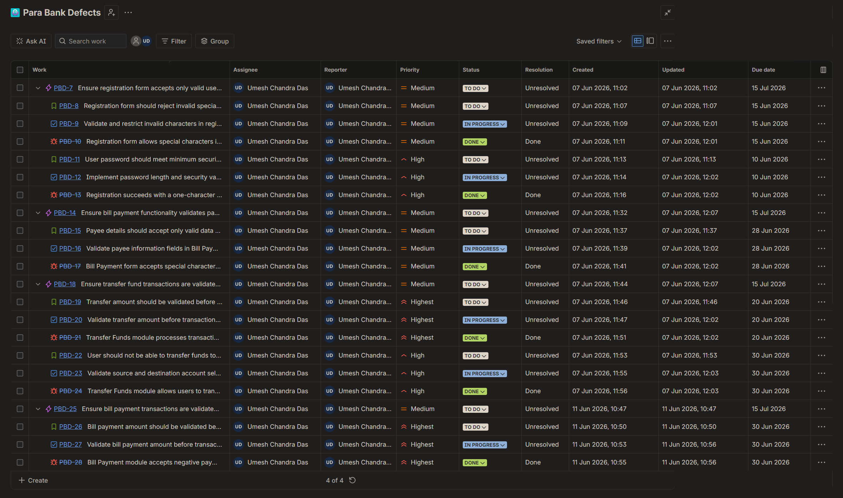
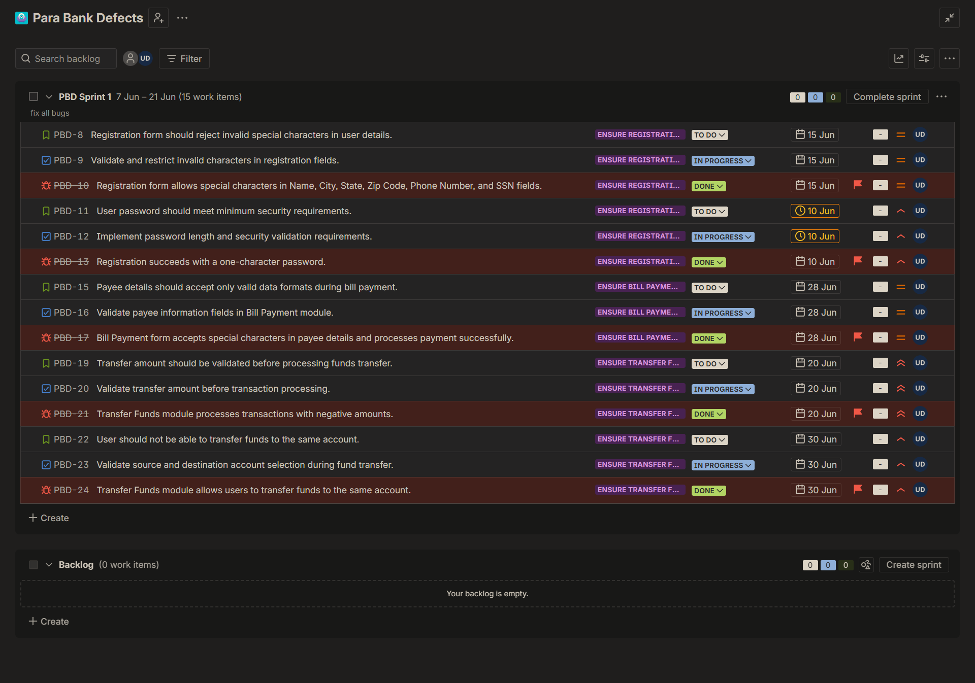
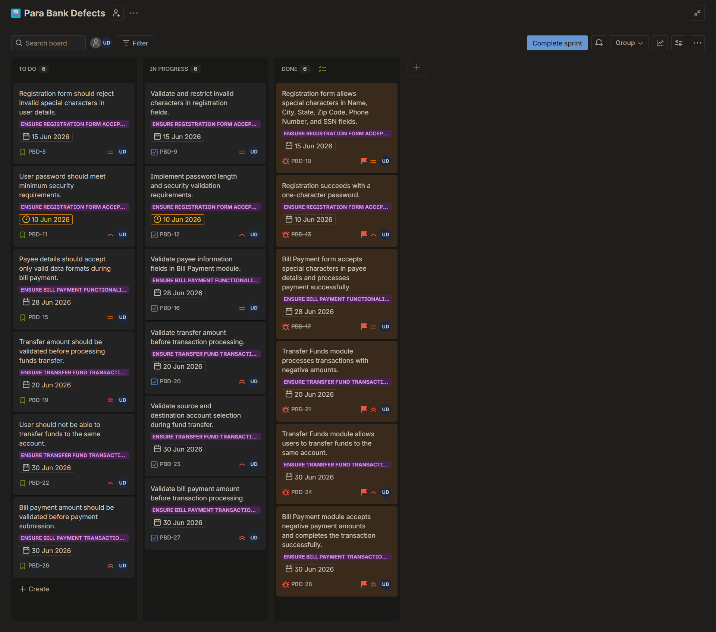

Defect Details
Defect ID: PBD-10
Defect Summary:
Registration form allows special characters in Name, City, State, Zip Code, Phone Number, and SSN fields.
Module:
Registration
Test Case ID:
TC_REG_008
Test Case Name:
Validate Special Character Restrictions
Steps to Reproduce:
- Open ParaBank application.
- Navigate to Registration page.
- Enter special characters in Name, City, State, Zip Code, Phone Number, and SSN fields.
- Submit the registration form.
Expected Result:
System should reject invalid special characters and display validation messages.
Actual Result:
Registration form accepts special characters and completes registration successfully.
Severity:
Medium
Priority:
Medium
Status:
Fixed
Evidence:
Refer Screenshot:
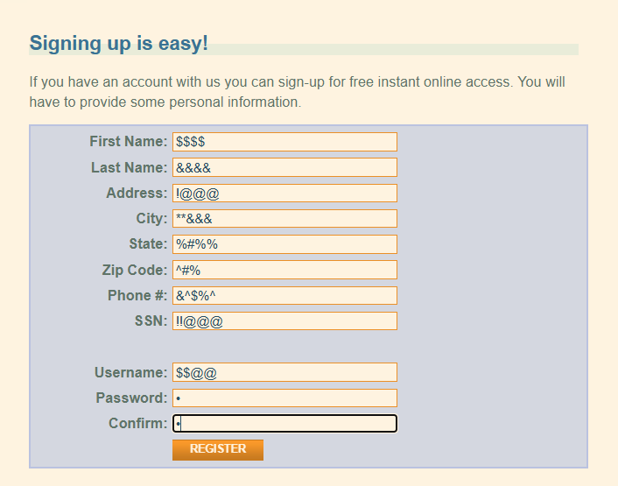
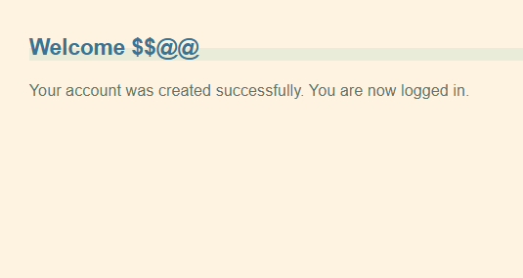

Defect ID: PBD-13
Defect Summary:
Registration succeeds with a one-character password.
Module:
Registration
Test Case ID:
TC_REG_012
Test Case Name:
Validate Password Length Requirements
Steps to Reproduce:
- Open Registration page.
- Enter valid user details.
- Enter password with only one character.
- Submit the registration form.
Expected Result:
Password should meet minimum length requirements.
Actual Result:
Registration succeeds with a one-character password.
Severity:
Critical
Priority:
High
Status:
Fixed
Evidence:
Refer Screenshot:



Defect ID: PBD-17
Defect Summary:
Bill Payment form accepts special characters in payee details and processes payment successfully.
Module:
Bill Payment
Test Case ID:
TC_BP_007
Test Case Name:
Validate Payee Details Input Validation
Steps to Reproduce:
- Login to ParaBank.
- Navigate to Bill Payment.
- Enter special characters in Payee Name and related fields.
- Submit the payment.
Expected Result:
System should reject invalid special characters.
Actual Result:
Payment is processed successfully despite invalid input.
Severity:
Medium
Priority:
Medium
Status:
Fixed
Evidence:
Refer Screenshot:
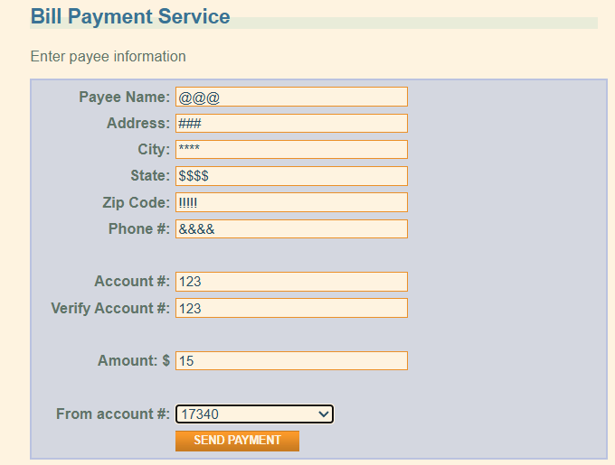
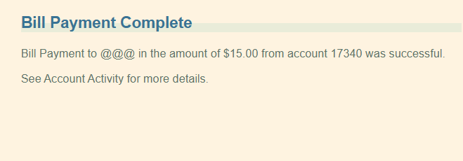

Defect ID: PBD-28
Defect Summary:
Bill Payment module accepts negative payment amounts and processes the transaction successfully.
Module:
Bill Payment
Test Case ID:
TC_BP_008
Test Case Name:
Validate Bill Payment Amount
Steps to Reproduce:
- Login to ParaBank.
- Navigate to Bill Payment page.
- Enter valid payee information.
- Enter valid account details.
- Enter negative amount (-32).
- Select source account.
- Click Send Payment.
Expected Result:
System should reject negative payment amounts and display validation message.
Actual Result:
Payment is processed successfully and confirmation page is displayed with negative amount.
Severity:
High
Priority:
High
Status:
Fixed
Evidence:
Refer Screenshot:
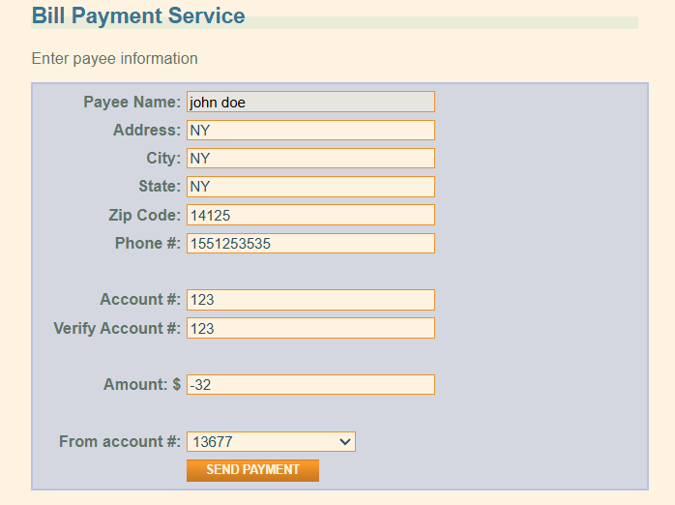
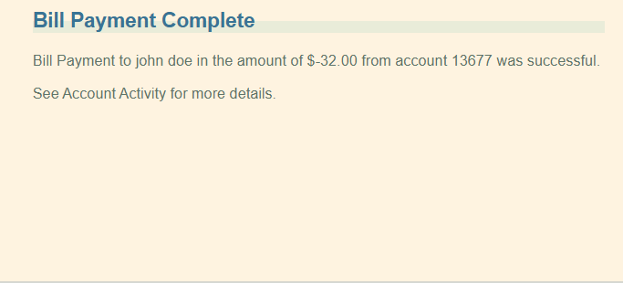

Defect ID: PBD-21
Defect Summary:
Transfer Funds module processes transactions with negative amounts.
Module:
Transfer Funds
Test Case ID:
TC_TF_005
Test Case Name:
Validate Transfer Amount
Steps to Reproduce:
- Login to ParaBank.
- Navigate to Transfer Funds.
- Select source and destination accounts.
- Enter negative amount (-20).
- Click Transfer.
Expected Result:
System should display validation message and prevent transfer.
Actual Result:
Transfer is completed successfully.
Severity:
High
Priority:
High
Status:
Fixed
Assigned To:
Developer
Evidence:
Refer Screenshot:
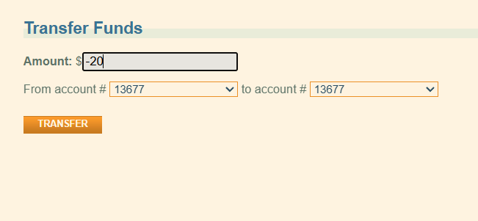
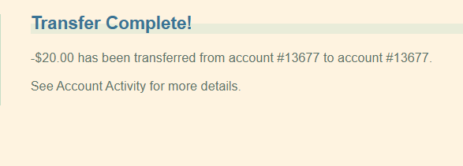

Defect ID: PBD-24
Defect Summary:
Transfer Funds module allows users to transfer funds to the same account.
Module:
Transfer Funds
Test Case ID:
TC_TF_006
Test Case Name:
Validate Source and Destination Account Selection
Steps to Reproduce:
- Login to ParaBank.
- Navigate to Transfer Funds.
- Select the same account as source and destination.
- Enter valid amount.
- Click Transfer.
Expected Result:
System should prevent transfer and display validation message.
Actual Result:
Transfer is processed successfully.
Severity:
Medium
Priority:
Medium
Status:
Fixed
Assigned To:
Developer
Evidence:
Refer Screenshot:



CONCLUSION
A total of six defects were identified during automation testing of the ParaBank application. The defects were related to input validation, password validation, bill payment validation, and business rule enforcement within Registration, Bill Payment, and Transfer Funds modules.
All identified defects were logged in Jira, assigned to the development team, fixed, and verified successfully through retesting.
Total Defects Identified: 6
Critical: 2
High: 2
Medium: 2
Low: 0
Defect Closure Status: 100% Closed

